FOOD ORDERING MANAGEMENT SYSTEM

PROJECT INTITATION DOCUMENTATION

SOLENT UNIVERSITY

Module : Process Analysis and Requirement Engineering – BCC607

Accessor Name : Mr. Parabudha

Name : Fathima Shenaz Buhari

Contents

1. Introduction 4

1.1 Background 4

1.2 Project Focus 4

1.3 Stakeholders 5

1.4 Aims & Objectives 6

1.5 Structure Approach to Requirement Analysis 7

1.6 Project management Approaches 8

1.7 Project overview 9

2 Requirement engineering Approaches 10

2.1 Feasibility Study 10

2.1.1 Technical Feasibility 10

2.1.2 Operational Feasibility 10

2.1.3 Financial Feasibility 10

2.2 Collecting and Analysing Requirements 11

2.3 Define scope 12

2.4 Project planning 13

3 Project management 16

3.1 Time management 16

3.2 Resource management 18

3.3 Risk management 18

3.4 Cost management 20

4 Project Control 20

5 Project Evaluation 20

5.1 Value addition to the project 20

5.2 Benefits 20

6 Personal Contribution 21

6.1 Workload 21

6.2 Personal quality of the works 21

7 References 22

Table of Figures

Figure 1 REP 7

Figure 2 Spiral model 8

Figure 3 Gantt chart 1 14

Figure 4 Gantt chart 2 14

Figure 5 Gantt chart 3 14

Figure 6 Plan 15

Figure 7 Risk management 18

Table 1 stakeholders 5

Table 2 Internal Stakeholders 5

Table 3 External Stakeholders 5

Table 4 Software components 11

Table 5 Hardware Components 11

Table 6 project Plan 13

Table 7 Time management plan 17

Table 8 risk identifications 19

Table 9 Tools and techniques of Risk analysis 19

# Introduction

## Background

Restaurant requested my team to do an application for food ordering. They were so struggling at the peak hours to communicate between chefs and waiters. They both have many miscommunication issues and they unable to deliver appropriate food for the customers. They may think it will affect to their goodwill. Therefore, they decided to change the manual system to computerized. According to that our application will be a solution to them.

Food ordering system is an application to make their day to day restaurant work easier.it will help to optimized and control their outcomes without having wastage. Chefs do not bother about waiters, if they come late and waiters do not have to go kitchen to give the orders. Because of the application They both can work with peace and relax. It will help to increase interest and the efficient of workers.

## Project Focus

The application can use for managers, waiters, chefs inside the kitchen, delivery boys, and also higher section persons of the restaurant with their position privilege. Which means, once the order will enter, it will automatically store the records in the database. Managers can control the orders according to the inventory limit age. Other managers can control the staffs and their shifting. Higher sector persons can measure each employee with their orders and records. Sametime they can analyse the day to day fast moving products and they can modify their low selling products.

This application may help to enhance the revenue of the restaurant, to do all the functionalities more accurately with short time period. This will improve the satisfaction of the customers among the restaurant.

## Stakeholders

Stakeholders means the interested parties in our company or business. They are affected by both internally and externally to our company. Somehow, they are participating to some roles in our company. Such as,

Table stakeholders

Internal Stakeholder

They have more influence on the company. They are directly affected to the performance of the company. And also directly involved to the company’s success or failure.

|  |  |
| --- | --- |
| The Owner | The person who had the control and lead the company. He is responsible to company cost, income and expenses. |
| Board of directors | They make decisions in appropriate time. |
| Mangers | They control the restaurant by having records. |
| Staffs | They work for improve the company income. |
| investors | They give the capital to gain the future financial return. |

Table Internal Stakeholders

External Stakeholders

They are not working inside of the company; they are outside people but somehow affected by the actions and decisions.

|  |  |
| --- | --- |
| Competitors | Regularly visit to the restaurant and they make equal product as our restaurant |
| Customers | They buy foods and involved to revenue. |
| Suppliers | They give goods for make products. |

Table External Stakeholders

## Aims & Objectives

Aim

Solve their manual operational issues and Fulfil their requirements to increase their restaurant growth.

Objectives

* Learn how they faced challenges by the manual system.
* To study the functionalities of Food ordering Management system.
* Learn how to design a complete computerized system based on the scenario.
* To study how to split the workload among team according to food ordering scenario.

## Structure Approach to Requirement Analysis

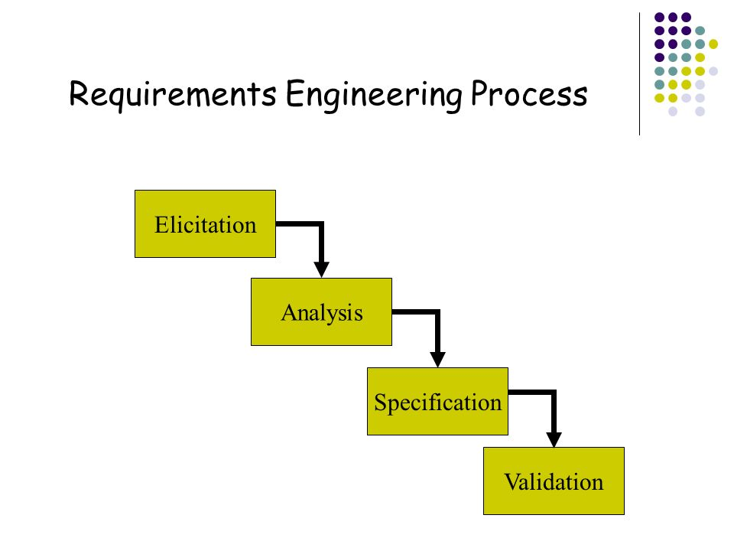We cannot start the project without any requirements. Before the start up we have to understand the scenario and current situation accurately. Because of that we can understand, who are the target audience. Thus, we need requirements. I explained those in below.

Figure REP

* Elicitation – According to our consideration requirement gathering is the main part of the project. Once you done that properly you do not worry about the end. Why I mentioned like this Because that is the important need of the company. according to that we are planning, design the architecture, implement the system. Therefore, gathering requirements are not an easy process.in this case there are many methods. We Gathered information by interviews, meetings, discussion with stakeholders. And also, we done many observations, Document analysis. We gave questionnaires to employees to understand their needs and expectations.
* Analysis – in this stage we organized the overall requirements and categorized them as how we planned. After that we identified the relationships and issues among that. After the categorization we move to the architectural designs with appropriate plan.
* Specification – in this stage we can developed the SRS and Project initiation documents among these requirements.
* Validation – this is the stage client will confirm the project which means, we have to explain each and every area of the system briefly. If he is not satisfied with our designs and plans, we have to organized the system again or we can compromise them. But fortunately, our clients are satisfied with our system and they are encouraged us.

## Project management Approaches

Spiral Model

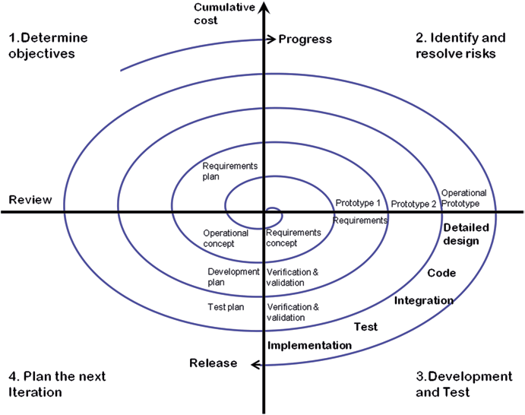

Figure Spiral model

We chose spiral model for our project because if there any new changes will come, those are expected during the development cycle. Same time we have Risk analyzation in each stage and also it is a combination of waterfall and prototype. There are many prototype steps in start to middle. therefore We can gather accurate and appropriate requirements as well as we can change our requirements in middle or last as clients wish.

The major advantage of the Spiral model is Clients can look the project begin to end and can gather quick user feedback because the user directly involves to the system. I consider all these points and I defined spiral model is suitable for our scenario because it has a combination of iterative development process model and sequential liner development model as well.

## Project overview

Inside the restaurant they all working over the manual system. Which means, the waiter has to note the order and he has to deliver to the chefs who inside the kitchen to prepare the food according to customer’s order. Obviously, there is chance to be misplacing the foods. Which means waiters were serves the food for wrong table. Or the chefs made the wrong food. At the same time mangers do not have a proper sales record. It may cause to decrease company revenue and sales. Likewise, they had many of issues in manual system. Then they decided to change to computerized system. Therefore, my team takeover the project to conclude the issues and help them to enhance the revenue and their goodwill.

Food ordering system is made to solve their operational issues. Which means, once the waiter will enter the order automatically it displays on the kitchen, then the chef will prepare it. Next, he will hand over to the waiters with label of the table which was ordered it. While the waiter entered the order that record will save on the database also. Therefore, at the time Mangers or higher sector staffs also can check the sales.

There is another advantage in the system is chefs can mark what are the ingredients or production items going low and has to fill.it automatically inform to the inventory section and they can refill it soon as possible. Consequently, chefs can make any product as customer’s wishes. That quality will enhance the customer’s satisfaction.

There is another privilege to delivery boys also. If an order ready for the delivery, once the staff clicked it as delivery automatically it passes the message to the delivery boy who are available because once they ready for the delivery they have login to the system, then the system will recognize he is available for delivery.

We believe as a team our Food ordering Management system will coverup all the issues inside the restaurant and it gives a satisfaction to the client and the all kind of employees who are related and worked to the restaurant. It makes the day to day work easier. Same time it may Reduce the wasting time also. We believe the system will increase the workers effectiveness and productivity.

# Requirement engineering Approaches

## Feasibility Study

We use Feasibility study for understand thoroughly all kind of phases of the projects and also be prepared for upcoming issues while implementing.

### Technical Feasibility

This is considered about technical equipment for the proposed project. In the system, our software and hardware components have to be satisfied the user requirement. In that case we use visual studio for implementing because the speed of output is very fast and quick. And also, easy to implement and debug.

I have selected MYSQL for database management because it had great security, backup and recovery. we can handle huge number of data over that.

### Operational Feasibility

While we consider about this area, it will measure the how far the proposed system solves their problems. workers done their work by manual. They cannot change automatically to the computerized. Thus, we have to give a train to them. It takes time but it will improve their effectiveness.

### Financial Feasibility

“This will consider about what are the financial aspects of the project. This may determine the proposed project possible to takeover or not. This will evaluate the start-up cost, cashflows and also operating expenses.” (Woodruff, 2020)

## Collecting and Analysing Requirements

The Food ordering management system need order details, food details, delivery items, fast moving items, staff details and so on. Our system will identify these things.

Software Requirements

I can mention the software requirements for the proposed system below.

|  |
| --- |
| Windows 10 operating system |
| Visual studio to implement the system |
| MYSQL database for developing the database system |
| Avast virus guard to protect the system |
| Dropbox for storage procedures |

Table Software components

Hardware Requirements

I mentioned the hardware components below.

|  |  |
| --- | --- |
| Components | Quantity |
| Nodes (It may include monitor, keyboard, mouse, motherboard) | 2 |
| CPU intel core i5 | 2 |
| Main Memory (4GB RAM) expansion card, power supply unit | 2 |
| Hard disk drive | 1 |
| Graphics Card | 2 |
| Network interface card | 2 |
| WIFI Router | 1 |
| LED Screen | 2 |

Table Hardware Components

## Define scope

The main purpose of the system is to avoid unwanted wastages because of miscommunication among the chefs and waiters. Which means waiters collect the orders and tell to chefs, sometimes chefs were hearing the wrong item and produce the incorrect one mistakenly. And also, chefs forgotten to made some of foods which they are ordered. Thus, customers got angry on waiters and they cancelled their orders also.

Therefore, customers complain to the management to tell they are not satisfied for the services and so on. It was the huge error in the manual system.

the scope of the system is to maintain a proper communication between chefs and waiters and help them to improve their services and company revenue.

The waiters can mark the orders among application and it displays on the chef’s LED Screen and they make those food according to the suitable order, while they finished it, they can alert the waiters soon as possible. After that waiters can produce the food to the customer with limited time period.

The application will reduce the wastage time, unwanted manpower usages and improve the customer satisfaction as well.

## Project planning

Below diagram will categorized each stages of the project.

Table project Plan

Below Screenshot will reflect the Gantt chart of the project.

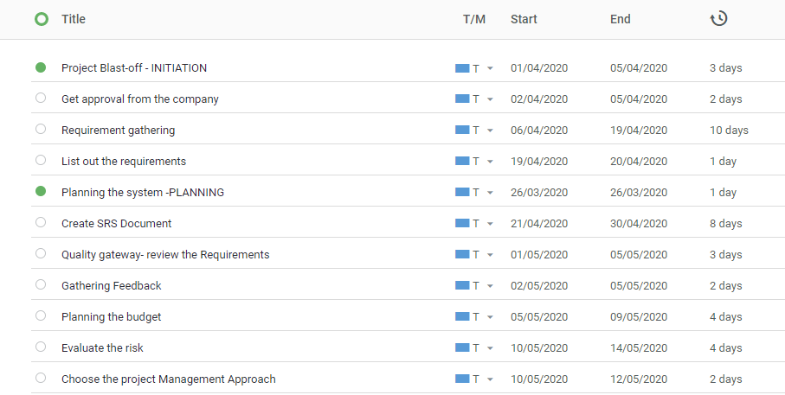

Figure Gantt chart 1

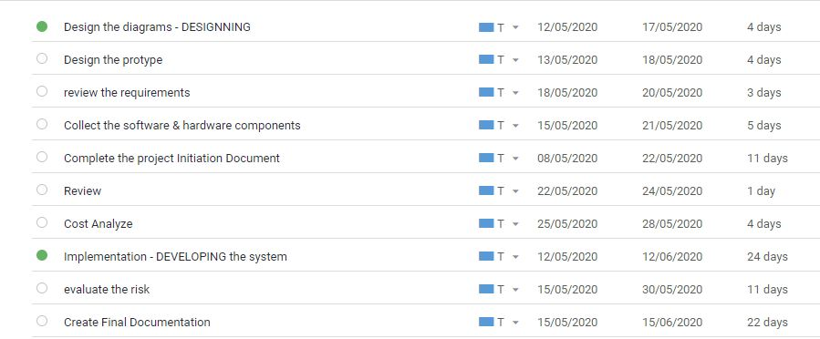

Figure Gantt chart 2

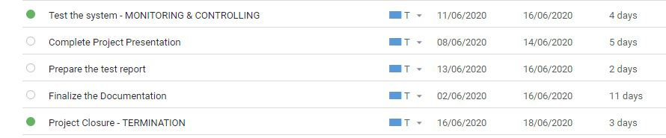

Figure Gantt chart 3

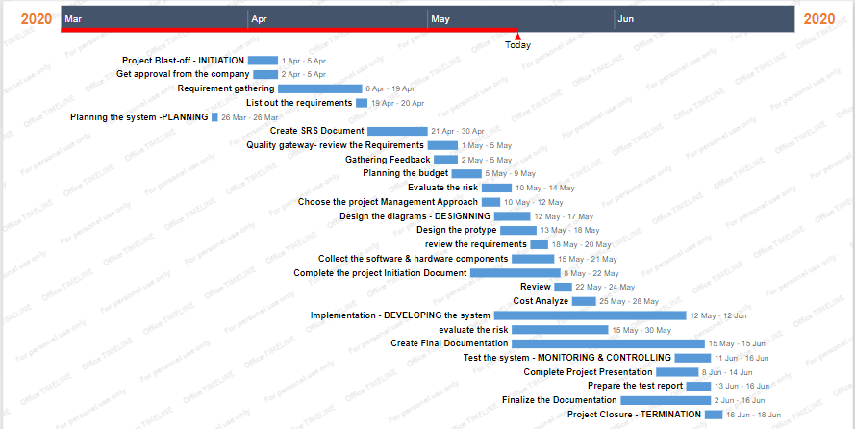

Figure Plan

# Project management

## Time management

Time management is an important part of a project. It helps to organize the workload in efficient way. If we planned our works according to a time schedule, we can understand the work for each day and we can complete them as fast which means we can avoid the distractions as well. Planning helps to identify the all tasks which were need to complete for project. After that we can estimate the time for each. This may help to improve the performance of the project. Below table categorized the workload.

|  |  |  |  |
| --- | --- | --- | --- |
| Task | | Start date | End date |
| 1 | Project Blast-off- get approval from the company | 01-04-2020 | 05-04-2020 |
| Requirement Gathering | | 06-04-2020 | 19-04-2020 |
| List out the requirements | | 19-04-2020 | 20-04-2020 |
| 2 | Planning the system | 20-04-2020 | 26-04-2020 |
| Choosing the project management approach | | 10-05-2020 | 12-05-2020 |
| Planning budget | | 05-05-2020 | 09-05-2020 |
| Identifying the software & hardware components | | 10-05-2020 | 12-05-2020 |
| Quality gateway- review the requirements | | 15-05-2020 | 18-05-2020 |
| According to the feedback Planning the system | | 18-05-2020 | 20-05-2020 |
| 3 | Designing the diagrams (ER diagram, Data flow diagram, Class diagram) | 12-05-2020 | 17-05-2020 |
| Design the prototype | | 18-05-2020 | 22-05-2020 |
| Review the requirements | | 18-05-2020 | 22-05-2020 |
| Complete the PID & SRS | | 08-05-2020 | 21-05-2020 |
| Review | | 21-05-2020 | 24-05-2020 |
| Cost Analyse | | 25-05-2020 | 28-05-2020 |
| 4 | Implementation- developing the system | 12-05-2020 | 12-06-2020 |
| Evaluate the risk | | 15-05-2020 | 30-05-2020 |
| 5 | Monitoring & controlling | 10-06-2020 | 16-06-2020 |
| Testing the system | | 11-06-2020 | 16-06-2020 |
| 6 | Termination | 13-06-2020 | 18-06-2020 |
| Prepare Test report | | 13-06-2020 | 16-06-2020 |
| Project presentation | | 8-06-2020 | 14-06-2020 |
| Finalize the Documentation | | 02-06-2020 | 16-06-2020 |
| Project closure | | 16-06-2020 | 18-06-2020 |

Table Time management plan

## Resource management

“Resource management means a allocate our resources to maximize efficiency.it is a process of pre-planning.” (Hansen, 2018)

First a fall we have to identify what are the resources need for our project. That means humans, things, money, hardware components and all belongs to resources. Before we start the project, we have to listed down those resources which we going to use. If we want to make our system successful, we have to plan our resources effectively according the requirements. It will avoid the money and time wastage.

## Risk management

Risk is an unexpectable consequences, before it occurs, we have to maintain some pre plans for mitigate that. Successful projects are never frightened to risks. Therefore, Risk management is essential part of a project. If we unable to solve the risk, it might interrupt to your project outcomes.

There are some steps in Risk management process. I mentioned those in below.

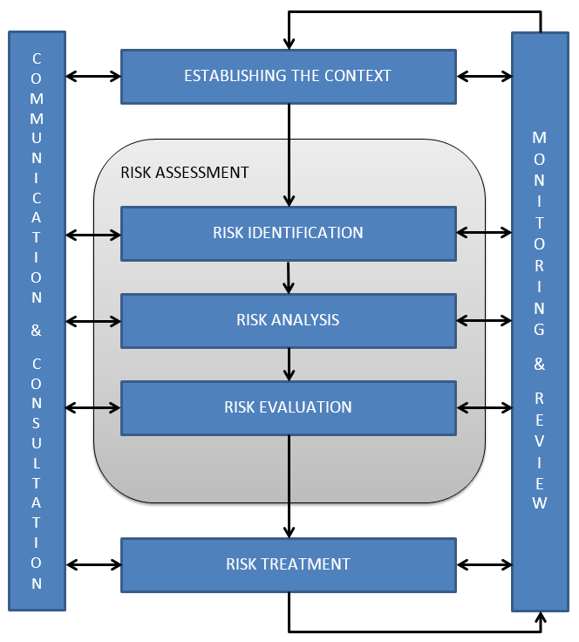

Figure Risk management

There are some techniques in risk identification. Such as,

Table risk identifications

There are some tools and techniques to Qualitative the Risk Analysis. There are,

Table Tools and techniques of Risk analysis

(Greycampus, 2020)

## Cost management

Our project success is based on proper cost estimation. If a project exceeded the budget it may cause a risk in financial phase. There are some tool and techniques help to estimation. Such as,

* Expert judgement – take information from experts.
* Analogous Estimation- take details from previous projects.
* Cost of quality – estimate the cost with both conformance and non-conformance expenses.
* Vendor Analysis – compare with different bids by vendors for estimation.

(Christine, 2020)

# Project Control

This may explain about how our project was manged, monitored and controlled. Such as,

* We conducted weekly team meetings and gatherings
* Regular project reviews
* Conduct Risk mitigation plans (I mentioned those in Risk management section)
* Check the quality control and team performance repeatedly
* Respond to changes of the clients
* Provide guidance to the team
* Mange issues

# Project Evaluation

## Value addition to the project

* Improve the security path. Focus on cybersecurity
* Do not hide the budget from clients
* Maintain the transparency of the project with clients
* Improve the system with new ideas
* Fulfil client’s requirements
* Improve the documentations of the project

## Benefits

* The system will helps develop the efficiency of worker
* It is helps to improve the productivity
* It will help to increase the sales
* It will enhance the revenue of the company
* It helps to improve the goodwill of company because of customer satisfaction.

# Personal Contribution

## Workload

In our team there are seven members. Those are,

* Team leader – Handle the team, take decisions and controlling the team as well.
* Requirement analyst – gather each and every requirement
* Project manager - Choose the project management approach and maintain the team according to the methodology
* System Architecture – Design the application, Diagrams, protypes
* System developer – Implement the system
* Software Engineer – Monitoring the system
* Tester - Fix the bugs

All members are involved to risk management as well.

## Personal quality of the works

I am the team Leader of the project and am the one played main role in the project.

I cooperate with team members and I listened to their ideas as well. If they unable or missed something in their work I helped them to fulfil it.

I motivate my team members regularly and help them to focused on objectives. We had a confident to achieve the goal. We conduct meetings regularly to enhance the creativity, generate new ideas and I plan to mitigate some risks.

And also, I have to take decisions, monitor each stage and also enhance team performance as well. Same as I demonstrate each work considered by team member’s talent and skills. Which means, I categorized the work among the member’s talents. therefore, they put the depth knowledge in that area to fulfil the work. And also, I support them in different ways.

The main thing is to identify the end goal of the project. In our team I understood that and I explained to the other members. This project improved my team managing skills and I believe that I am a qualitative complete finisher.

# References

Greycampus.com. 2020. *Greycampus*. [online] Available at: <https://www.greycampus.com/opencampus/certified-associate-in-project-management/risk-identification-tools-and-techniques-in-capm> [Accessed 20 May 2020].

Woodruff, J., 2020. *How To Prepare A Financial Feasibility Study*. [online] Bizfluent. Available at: <https://bizfluent.com/how-8048004-prepare-financial-feasibility-study.html> [Accessed 18 May 2020].

Christine, S., 2020. *Top 10 Tools And Techniques To Estimate Project Cost*. [online] Tutorialspoint.com. Available at: <https://www.tutorialspoint.com/top-10-tools-and-techniques-to-estimate-project-cost> [Accessed 19 May 2020].

Hansen, B., 2018. *What Is Resource Management & Why Is It Important?*. [online] Wrike.com. Available at: <https://www.wrike.com/blog/what-is-resource-management/> [Accessed 19 May 2020].